

**Quinn’s Baptist College**

**NAME: _____________________________________**

**Year 11 ATAR Psychology Examination**

**Structure**

|  |  |  |  |
| --- | --- | --- | --- |
|  | **Section 1** | **Section 2** | **Section 3** |
| **Time Allocated** | **Research Methods** | **Short Answer** | **Extended Answer** |
| **Marks Allocated** | **40** | **70** | **20** |

**Total /130**

**Time allowed for this paper**

Reading time before commencing work: Working time for paper:

3 hours and 10 minutes reading time

**Materials required/recommended for this paper**

***To be provided by the supervisor***

This Question/Answer Booklet

***To be provided by the candidate***

Standard items: pens (blue/black preferred), pencils (including coloured), sharpener, correction fluid/tape, eraser, ruler, highlighters

Special items: non-programmable calculators approved for use in the WACE examinations

**Important note to candidates**No other items may be taken into the examination room. It is **your** responsibility to ensure that you do not have any unauthorised notes or other items of a non-personal nature in the examination room. If you have any unauthorised material with you, hand it to the supervisor **before** reading any further.

**SECTION 1: RESEARCH METHODS [40 Marks]**

**Question 1.**

Professor Livingston at Stanford College conducted an experiment that measured the academic benefits of taking fish oil (Omega 3) supplements. He asked for volunteers at a high school to participate in the experiment. To test his hypothesis, he divided the 20 participants into two conditions/groups. One condition was given fish oil tablets whilst the other control group was given a sugar tablet. Neither group knew which group was given the actual supplement. He used a numeracy tests to measure their academic performance. Participants wrote three different tests over a two-week period. After the trial, he was disappointed to find that there was not a significant difference between the group performances on the test.

1. Write an operational hypothesis for this experiment. [2 marks]

|  |
| --- |
|  |
|  |

1. Identify the dependent and independent variables. [2 marks]

|  |
| --- |
|  |
|  |

1. Use the space below to calculate the **mean** for Condition 1’s test performances on the last test:

The percentage scores were: 93, 78, 66, 45, 67, 71, 89, 78, 84 and 81.

[1 mark]

|  |
| --- |
|  |

1. What is the median of this data? [1 mark]

|  |
| --- |
|  |

1. What is the mode of this data? [1 mark]

|  |
| --- |
|  |

1. **Identify** the term that refers to the substance given to the control group that has no known medical effect. [1 mark]

|  |
| --- |
|  |

1. **Explain** what could have influenced the control group to improve in the same way that experimental group improved on the numeracy test. [1 marks]

|  |
| --- |
|  |
|  |
|  |
|  |

1. **Identify** a procedure that could have been implemented to avoid the invalid conclusions.

[1 mark]

|  |
| --- |
|  |
|  |

1. **Outline** **two** pieces of information about this research study that the researcher must provide to participants so that they can give informed consent. [2 mark]

|  |
| --- |
|  |
|  |

1. **Explain** what professor Livingston should do after the experiment has ended to ensure that the study was conducted ethically. [1 mark]

|  |
| --- |
|  |
|  |

**Question 2.**

A research study was conducted to examine the effects of alcohol consumption on feelings of sadness. Fifty adult participants were randomly assigned to either Group A or Group B.

Participants were individually engaged in the following sequence of tasks:

* Complete a mood rating scale
* Discuss with the researcher three recent times when they felt sad; the purpose of this was to induce a state of sadness in the participant
* Complete the mood rating scale a second time
* Drink a moderate amount of ‘alcohol’ over a 20 minute period
* Wait 20 minutes for the ‘alcohol’ to be absorbed by the body

All participants were told that they would be given a moderate amount of alcohol to drink. Participants assigned to Group A were given an alcoholic drink. Participants assigned to Group B were given a non-alcoholic drink that appeared to be an alcoholic drink.

1. State a hypothesis the researcher could have developed for this study. [1 mark]

________________________________________________________________________________________________________________________________________________________________________________________________________________________________________________________________

1. **Identify:**
2. the independent variable for this study [1 mark]

**_______________________________________________________________________**

1. the dependent variable for this study [1 mark]

**______________________________________________________________________**

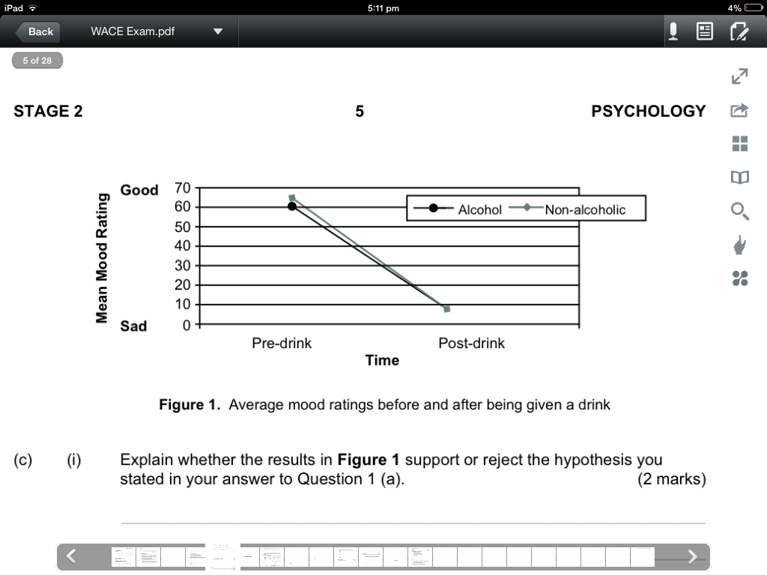

1. (i) **Explain** whether the results in **figure 1** support or reject the hypothesis you stated in your answer to Question 1 (a). [2 marks]

_________________________________________________________________________________________________________________________________________________________________________________________________________________________________________________________________________________________________________________________________________________________________________________________________

1. **Identify** **one** limitation of this study [2 marks]

__________________________________________________________________________________________________________________________________________________________________________________________________________________________________________________________________________________________________________________________________________

**Question 3. Define** what is meant by the **variance** of a distribution of scores on a psychological test.

[2 marks]

___________________________________________________________________________________________________________________________________________________________________________________________________________________________________________________________________________________

1. What does a **variance of zero** indicate about a distribution of test scores? [1 mark]

______________________________________________________________________________________________________________

1. **Explain** how test scores are distributed in a normal curve. [2 marks]

___________________________________________________________________________________________________________________________________________________________________________________________________________________________________________________________________________________

**Question 4.**

A research study was designed to investigate the extent to which children and adolescents associate tattooed individuals with antisocial (or negative) behaviours.

Data was collected using a task presented as a 20 page picture booklet entitled “Who is it?” Each page of the booklet showed a picture of three different men, one of whom was tattooed.

Below each set of pictures was a statement about the recent behaviour of one of the men. This was followed by the question ‘Who is it?’ Students were asked to tick the picture of the person whom they thought best matched the statement.

One third of the statements below each picture referred to positive (or pro social) behaviour, one third to anti-social behaviour and one third to neutral behaviour.

The researchers were interested in how often children associated positive (or pro social), negative (or anti-social), or neutral behaviour with the man with tattoos.

Scores were tallied for each type of association by scoring ‘1’ every time the students ticked the picture of the tattooed man, and ‘0’ when either of the other pictures was ticked. For each participant, this provided three stereotype scores (positive, neutral and negative choices), each with a possible range from 0 to 6. Mean scores for each age group studied are summarised in **Table 1** below.

**Table 1**. Mean stereotype scores by age

|  |  |  |  |
| --- | --- | --- | --- |
| **Age** | **Positive** | **Neutral** | **Negative** |
| **6 Years** | 2.24 | 1.50 | 3.17 |
| **8 Years** | 1.86 | 1.14 | 3.91 |
| **10 Years** | 1.17 | 1.23 | 4.27 |
| **12 Years** | 1.40 | 1.32 | 4.25 |
| **14 Years** | 1.44 | 1.33 | 3.84 |
| **16 Years** | 1.46 | 1.52 | 3.73 |

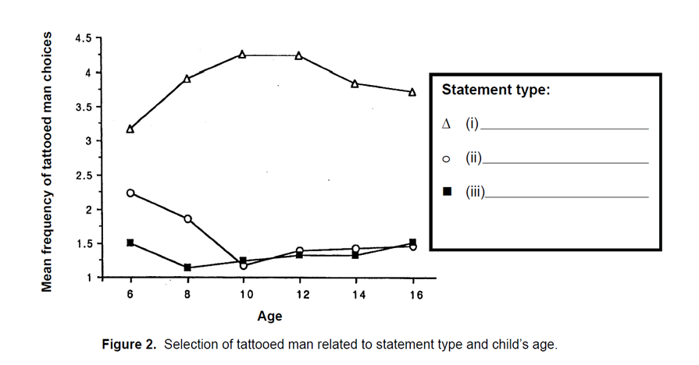

1. Consider the data in **Table 1** and the line graphs in **Figure 2** above. Use this information to correctly label the **‘Statement type’** for each line graph in figure 2 as positive, neutral or negative. [3 marks]
2. Name **two** variables other than gender that could have influenced student responses if researchers had not controlled for them. [2 marks]

Variable one: _________________________________________________________

Variable two: _________________________________________________________

1. Look at the trends in **Table 1 and Figure 2.** **Describe** what these findings suggest about the extent to which the children and adolescents in the study associated tattooed individuals with antisocial behaviours. [3 marks]

_______________________________________________________________________________________________________________________________________________________________________________________________________________________________________________________________________________________________________________________________________________________________________________________________________________________________________________________________________________________________________________________________________________________________________________________________________________________________________________________________________________________________

**Question 5.**

Dr. Rebecca Arrow wanted to examine the validity of Charles Spearman’s theories. She observed that scores on various different tests such as mathematics and memory were correlated highly with one another. Unlike Spearman, she found that even though mathematics and memory scores were highly related; that the scores on language tests were only slightly related to mathematics; and that scores examining bodily kinesthetic coordination had no correlation to the performances in mathematic tests. She displayed the correlational data on three separate graphs below.

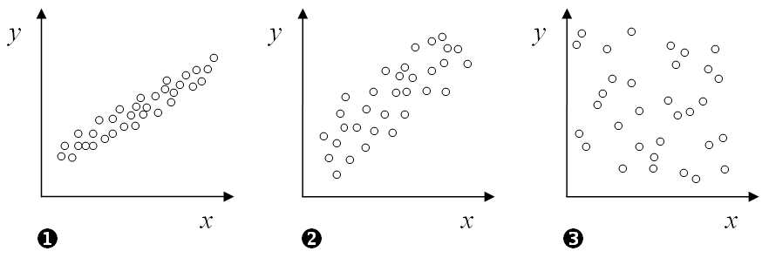

1. What are some benefits of displaying data on graphs? [2 marks]

|  |
| --- |
|  |
|  |
|  |

1. How would you describe the relationship for Graph 1? [1 marks]

|  |
| --- |
|  |
|  |

1. **Identify** which graph belonged to which of the following correlations (by writing the number in the space provided): [3 marks]

* Coordination and mathematics. Graph ____________
* Mathematics and memory. Graph _____________
* Language and mathematics. Graph ________________

1. Which of the following correlation coefficients would fit each of the graphs; [3 marks]
2. r = .25

Graph ______________

1. r = .5

Graph ______________

1. r = .7

Graph

______________

1. Nevertheless like Spearman, Dr. Arrow concluded that correlations between various abilities were positive but modest. What term did Spearman give to the fact that different tests measured the same factor of mental intellect? [1 mark]

|  |
| --- |
|  |
|  |

[TOTAL 40 MARKS]

**SECTION 2: Short Answer [70 Marks]**

**Question 5**: **Define** the following terms [5 Marks]

|  |  |
| --- | --- |
| Perception |  |
|  |
| Habituation |  |
|  |
| Divided Attention |  |
|  |
| Placebo Effect |  |
|  |
| Active Listening |  |
|  |

**Question 6:** **Describe** the different stages of Dexter Dunphy’s adolescent groups. [5 marks]

|  |
| --- |
|  |
|  |
|  |
|  |
|  |
|  |
|  |

**Question 7.** Why do psychologists have to be specially trained to use individual intelligence tests? [1 Mark]

|  |
| --- |
|  |
|  |

**Question 8.** What do we mean by cultural bias in intelligence tests? [2 marks]

|  |
| --- |
|  |
|  |
|  |

**Question 9:** Dr. Charles Xavier, a psychologist, has been hired by an advertising company to help them recruit more ‘intelligent’ employees. His first objective is to prepare a presentation on the importance of **‘emotional intelligence’** in the workplace. Briefly discuss the theory behind emotional intelligence and explain what evidence is there to suggest it is required for the workplace. [2 marks]

|  |
| --- |
|  |
|  |
|  |
|  |
|  |
|  |
|  |

**Question 10.** Which part of the brain plays a role in self-control and the expression of personality? Discuss the situation that led to this discovery? [3 marks]

|  |
| --- |
|  |
|  |
|  |
|  |

**Question 11.** Compare and Contrast a **MRI and PET scan.** [4 marks]

|  |
| --- |
|  |
|  |
|  |
|  |
|  |
|  |
|  |

**Question 12.** How did David Wechsler define intelligence? And what was Howard Gardner’s description of intelligence? [4 marks]

|  |
| --- |
|  |
|  |
|  |
|  |

**Question 13.** **Briefly identify** each of the FOUR physiological responses indicating different states of consciousness. Provide a brief explanation for each one. [8 marks]

|  |
| --- |
|  |
|  |
|  |
|  |
|  |
|  |
|  |
|  |
|  |
|  |
|  |
|  |

**Question 14.** **Describe** TWO the biological benefits of exercise. [2 marks]

|  |
| --- |
|  |
|  |
|  |

**Question 15**. Cathy drinks a lot of coffee. How would this particular drug affect her nervous system? (In your answer you should identify what type of drug it is) [2 marks]

|  |
| --- |
|  |
|  |
|  |
|  |

**Question 16.** **Discuss** THREE different states of consciousness [3 marks]

|  |
| --- |
|  |
|  |
|  |
|  |

**Question 17.** **Explain** how mental age and IQ (Intelligence Quotient) are measured and name the Theorists involved with the creation of this process. [4 mark]

|  |
| --- |
|  |
|  |
|  |
|  |

**Question 18.** Alison loves helping people. She finds fulfillment especially in volunteering at homeless shelters. Explain whether her behaviour demonstrates pro-social or altruistic behaviour. Give reasons for your answer. [2 marks]

|  |
| --- |
|  |
|  |
|  |

**Question 19**. **Evaluate** the three main theories of attraction. [3 marks]

|  |
| --- |
|  |
|  |
|  |
|  |
|  |
|  |
|  |
|  |

**Question 20.** Use **ONE** determination of liking to discuss how friendship can break down.

[1 mark]

|  |
| --- |
|  |
|  |

**Question 21**.

1. Using an example, explain the term **‘reciprocity’.** [2 marks]

|  |
| --- |
| Definition: |
|  |
| Example: |

1. Using an example, explain the term **‘Pro-social behaviour’.** [2 marks]

|  |
| --- |
| Definition: |
|  |
| Example: |

**Question 22.** Howard Gardner included ‘kinesthetic intelligence’ as one of his categories of Multiple Intelligence. **Describe** kinesthetic intelligence and give an example. [2 mark]

|  |
| --- |
| Description: |
|  |
| Example: |

**Question 23**. Using empirical evidence, give two examples how physical activity (exercise) can affect our wellbeing. [2 marks]

|  |
| --- |
|  |
|  |
|  |
|  |

**Question 24.** **Describe** the differences between a dyad, clique and a crowd. [3 marks]

|  |
| --- |
|  |
|  |
|  |
|  |
|  |

**Question** **25**. Use the diagram and table below to **label and describe** the functions of the following parts of the brain: Hindbrain, Forebrain and Midbrain. [6 marks]

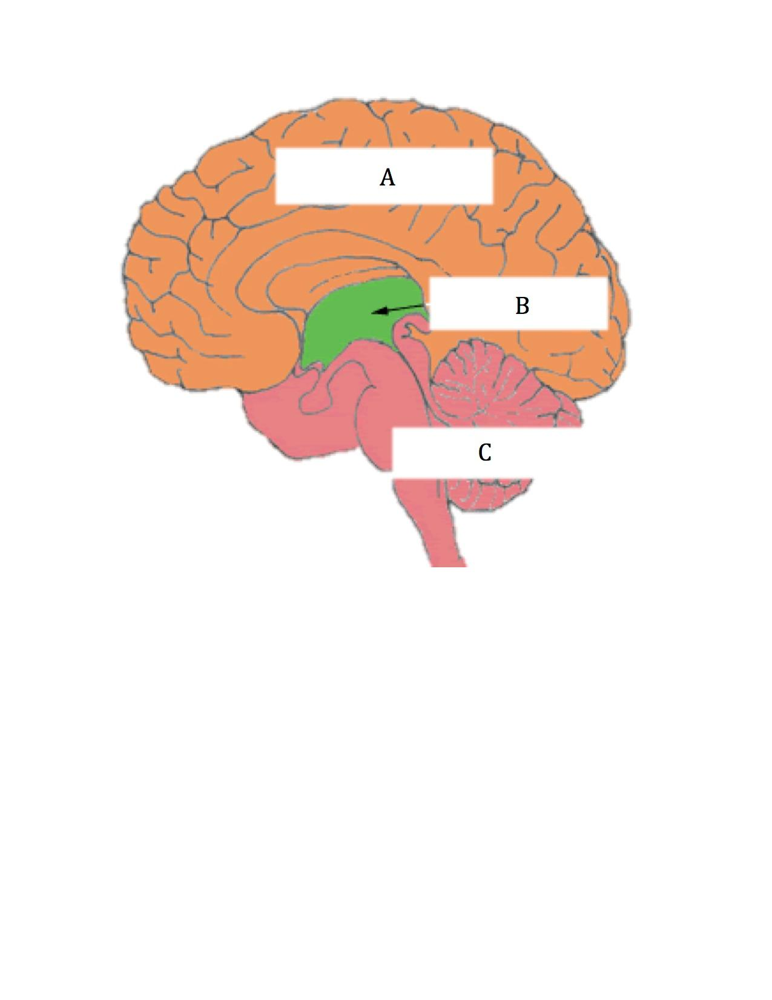

|  |  |
| --- | --- |
| Brain Area | Function |
| A) |  |
|  |
| B) |  |
|  |
| C) |  |
|  |

**Question 26**. What is the function of the Corpus Callosum? [2 marks]

|  |
| --- |
|  |
|  |

**SECTION 3: Extended Answer [20 marks]**

**Question 26. Discuss communication under the following headings:**

* Non-verbal communication
* Components of language
* Assertive communication
* Hearing Impairment and delayed communication
* Robinson’s social skills

|  |
| --- |
|  |
|  |
|  |
|  |
|  |
|  |
|  |
|  |
|  |
|  |
|  |
|  |
|  |
|  |
|  |
|  |
|  |
|  |
|  |
|  |
|  |
|  |
|  |
|  |
|  |
|  |
|  |
|  |
|  |
|  |
|  |
|  |
|  |
|  |
|  |
|  |
|  |
|  |
|  |
|  |
|  |
|  |
|  |
|  |
|  |
|  |
|  |
|  |
|  |
|  |
|  |
|  |
|  |
|  |
|  |
|  |
|  |
|  |
|  |
|  |
|  |
|  |
|  |
|  |
|  |
|  |
|  |
|  |
|  |
|  |
|  |
|  |
|  |
|  |
|  |
|  |
|  |
|  |
|  |
|  |
|  |
|  |
|  |

**END OF EXAM**